**Project Design Phase-II: Smart City Assistant**

|  |  |
| --- | --- |
| **Date** | **28 June 2025** |
| **Team ID** | **LTVIP2025TMID30062** |
| **Project Name** | **Sustainable Smart City Assistant Using IBM Granite LLM** |
| **Maximum Marks** | **2 Marks** |

1. **Data Flow Diagram (Example)**

The below diagram is a simplified Level-1 DFD of the Smart City Assistant.

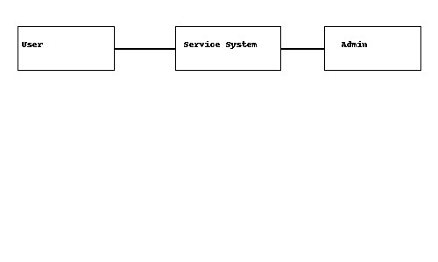

1. **User Stories (Tabular Format)**

|  |  |  |
| --- | --- | --- |
| **No** | **Role** | **User Story** |
| 1 | Citizen | I want to log in securely to the Smart City Assistant to access city services. |
|  |  |
| 2 | User | I want to request city services so that I get timely support. |
| 3 | User | I want to receive alerts about traffic, water supply, and emergencies. |
|  |  |
| 4 | Admin | I want to view all service requests so that I can manage and resolve them. |
|  |  |
| 5 | User | I want to submit feedback so that the system can improve over time. |
|  |  |